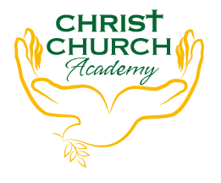
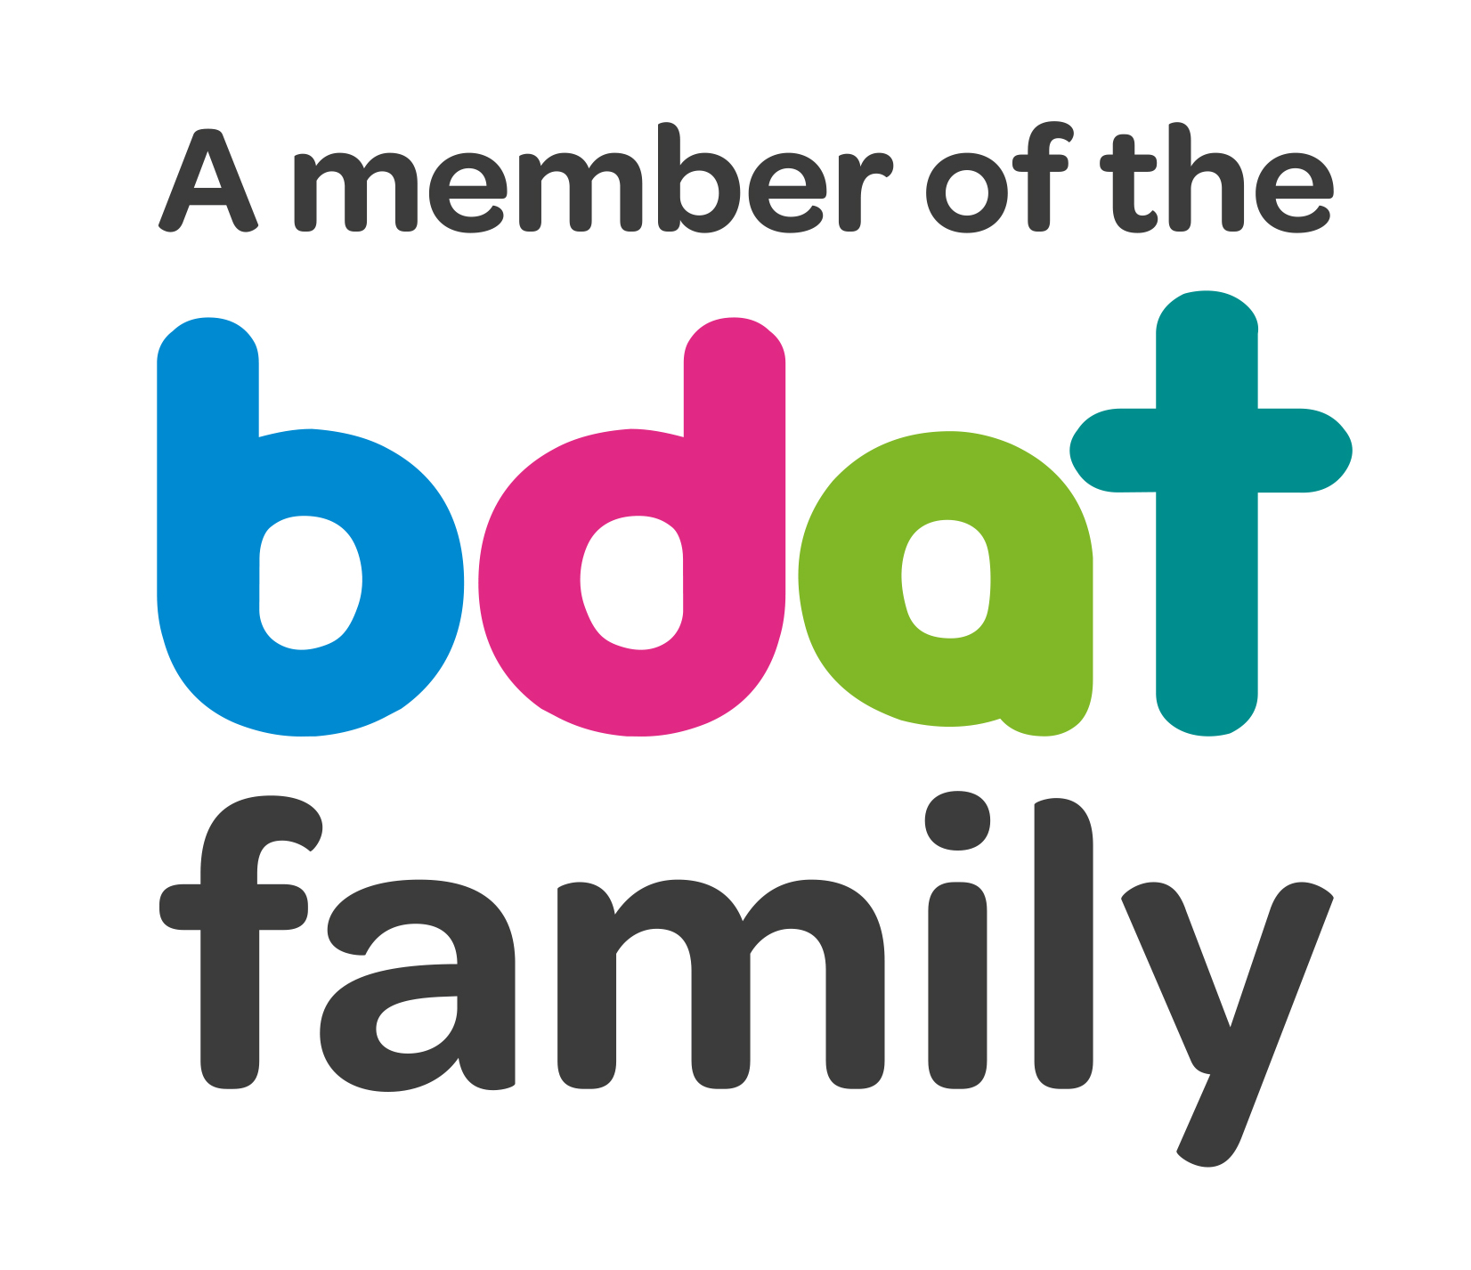
Christ Church Academy
Wrose Brow Road
Shipley
Bradford
BD18 2NT
01274 410349
admin@cca.bdat-academies.org
Headteacher: Mrs Philippa Foster

Date: Thursday 13th October 2022

Dear parents and carers,

Re: Change to Nursery session prices

We have kept our Nursery session price unchanged for many years now, however due to rising costs we are increasing the price to £12.00 per morning session and £12.00 per afternoon session with effect from Monday 31st October.

We believe this is still excellent value for money when compared with other nurseries.

This does not affect working parents with a 30 hour code for free childcare.

Please note that if your child is booked in for the same session every week they must attend that session only. If they do not attend, you will still be charged. This is a Nursery place that could be given to another child, and we still must cover our costs even if they do not attend.

If you need to change the sessions, they attend you need to apply to the school office providing at least two weeks’ notice.

If you have any queries please contact the school office.

Yours faithfully,

Mrs. Best
School Office

