
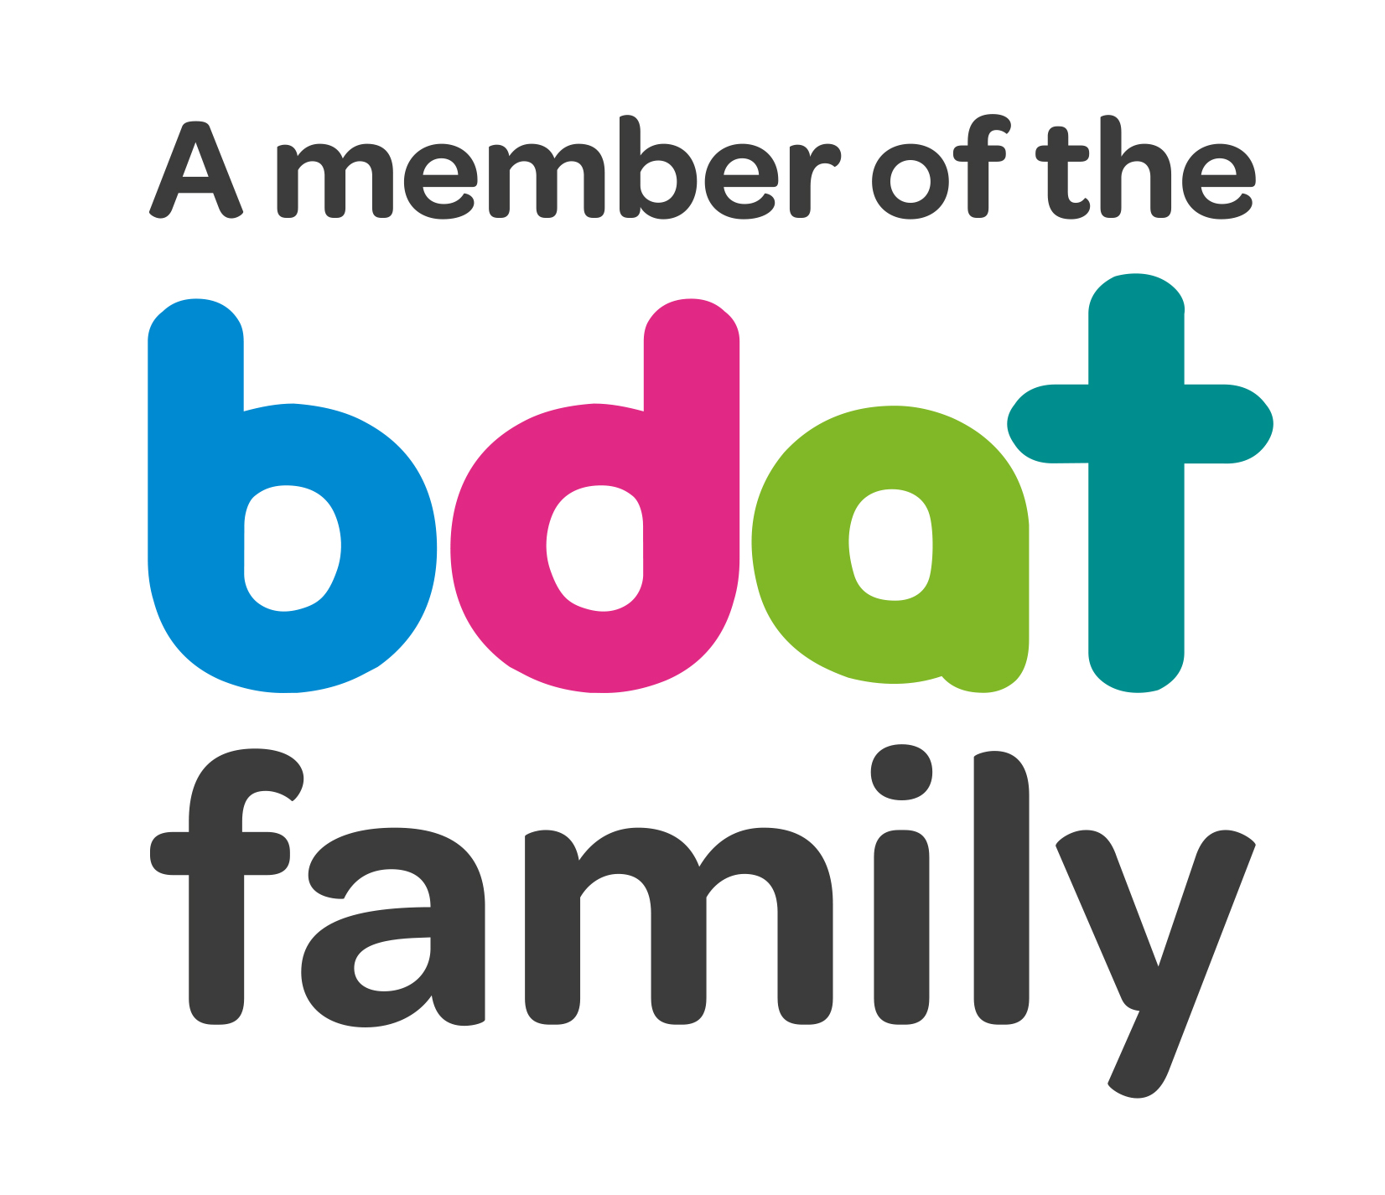
Christ Church Academy
Wrose Brow Road
Shipley
Bradford
BD18 2NT
01274 410349
admin@cca.bdat-academies.org
Headteacher: Mrs Philippa Foster

Date: Thursday 10th November 2022

Dear Parents and carers,

Re: School Trips and Activities – Reception class

Following two years of the pandemic we are hoping that this year sees a return to normality, and we will be able to introduce a plan of activities and trips for year groups from Reception to Year 6.

Each class will aim to have at least two school trips this year as well as four activities or visitors to their class.

School heavily subsidises the trips and visits, but we need our parents to contribute to the costs to help us provide this rich addition to the curriculum.

We are of course aware of the increasing cost of living, which has also impacted on venue costs and travel. To keep costs down we will be travelling on foot or by train as much as possible and will be using venues within the Bradford and Leeds areas as much as possible.

You can look at the plans for your child’s class on the other side of this letter. Please note these may be subject to change depending on availability and costs, and alternative trips may be provided.

To help us provide these trips and activities we are asking parents or carers to contribute £35.00 for the entire year. Considering the trips and activities we are offering we hope you agree this is a reasonable price.

A ParentPay item called Trips 22-23 will be applied to each child’s account. You are welcome to pay in instalments, from as little as £1, or pay it all at once. Please ensure that the full payment is made by 30th April 2023.

If you have any queries about the trips, please see your class teacher. For queries about ParentPay please contact the school office.

Yours sincerely,

Mrs. P.Foster
Headteacher

Reception Class proposed trips and activities (may be subject to change)

Term | Trip/activity
Autumn 1 | - Local Area visit – Storytime in the Local Woods and material collecting  - Soup Making – cihdlren to wash, chop and prepare the soup.
Autumn 2 | Local Area Visit - Visit to a local church to see the Advent and Nativity displays. Children given a Christmas Craft Pack and will make this in the church, followed by a picnic and games in the local park. Children then visit Shipley Library for rhyme time and to sign up for the Library. Children given a souvenir book to take home with their Christmas Craft Pack.
Spring 1 | Dinosaur Day! In school visit from a Dinosaur Expert and school-led Dinosaur activities, including a dig, baking, building and games.
Spring 2 | In school visit from Expressive Explorers Storytellers who will lead a Literacy Workshop on the tale ‘Stone Soup’.
Summer 1 | Visit to Tropical World in Leeds to tour the animal sanctuaries and experience a half-day learning workshop about Rainforests and habitats
Summer 2 | Visit to Eureka in Halifax to tour the museum and experience a Museum-led Science Show about Senses
Summer 2 | Local Area Visit to Saltaire. Children will visit Salts Mill and visit the David Hockney exhibition, then picnic and games in Robert’s Park. Children will then experience a Storytelling Workshop and Walking Tour of Saltaire.

