
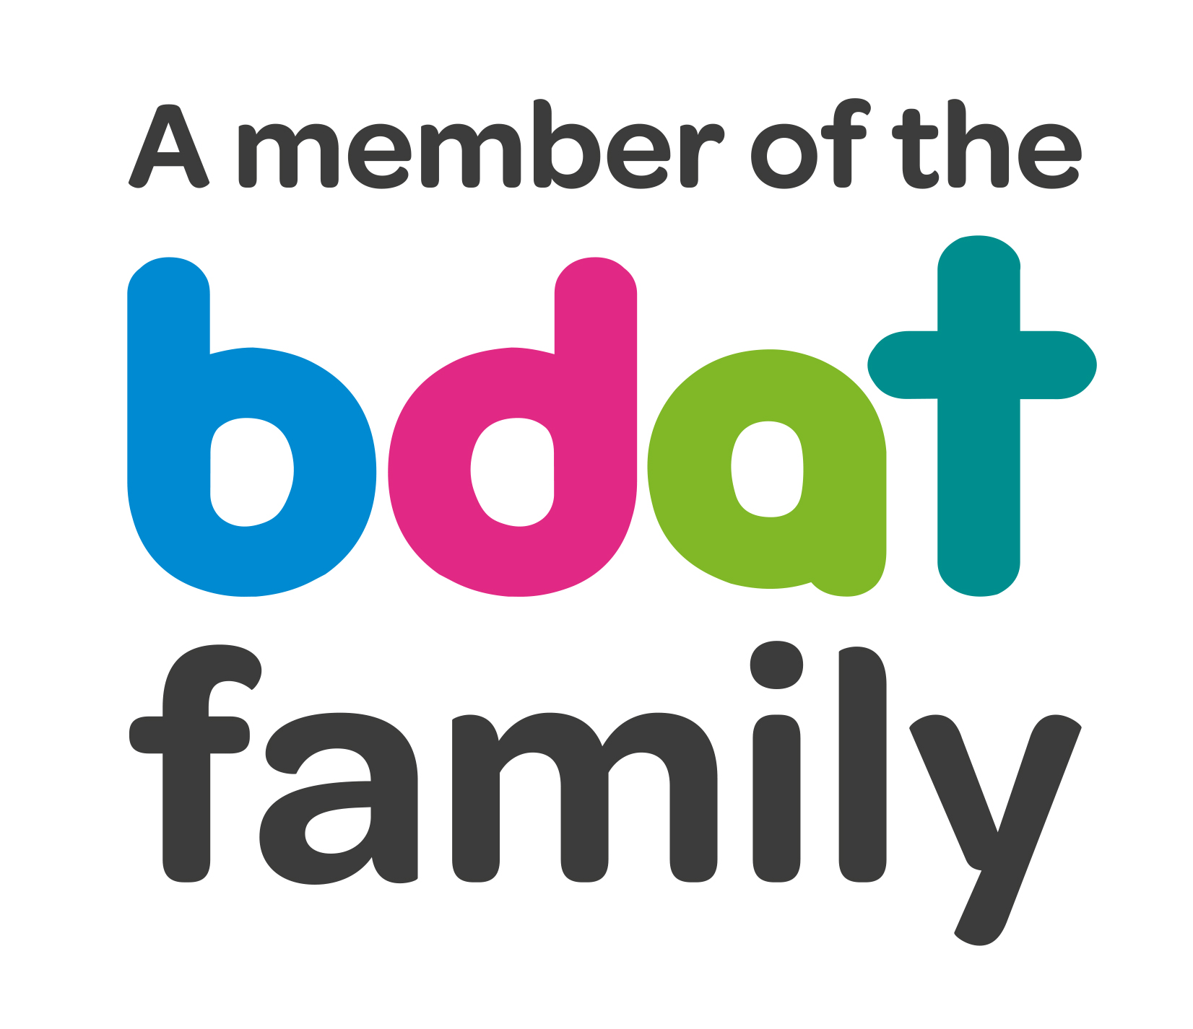
Christ Church Academy
Wrose Brow Road
Shipley
Bradford
BD18 2NT
01274 410349
admin@cca.bdat-academies.org
Headteacher: Mrs Philippa Foster

Date: Thursday 10th November 2022

Dear Parents and carers,

Re: School Trips and Activities – Year 3

Following two years of the pandemic we are hoping that this year sees a return to normality, and we will be able to introduce a plan of activities and trips for year groups from Reception to Year 6.

Each class will aim to have at least two school trips this year as well as four activities or visitors to their class.

School heavily subsidises the trips and visits, but we need our parents to contribute to the costs to help us provide this rich addition to the curriculum.

We are of course aware of the increasing cost of living, which has also impacted on venue costs and travel. To keep costs down we will be travelling on foot or by train as much as possible and will be using venues within the Bradford and Leeds areas as much as possible.

You can look at the plans for your child’s class on the other side of this letter.

To help us provide these trips and activities we are asking parents or carers to contribute £35.00 for the entire year. Considering the trips and activities we are offering we hope you agree this is a reasonable price.

A ParentPay item called Trips 22-23 will be applied to each child’s account. You are welcome to pay in instalments, from as little as £1, or pay it all at once. Please ensure that the full payment is made by 30th April 2023.

If you have any queries about the trips, please see your class teacher. For queries about ParentPay please contact the school office.

Yours sincerely,

Mrs. P.Foster
Headteacher

Year 3 proposed trips and activities (may be subject to change)

Term | Trip/activity
Autumn | Visit to the Media Museum to learn about light and computing.
Autumn | Den Building in the woods
Spring | Visit from the Peace Museum to school
Spring | Visit to Bracken Hall, Shipley Glen
Summer | Trip to Ilkley Tennis club
Summer | Trip to Tropical World, Leeds

