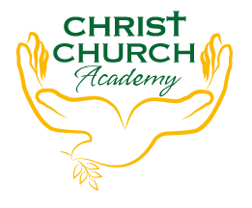
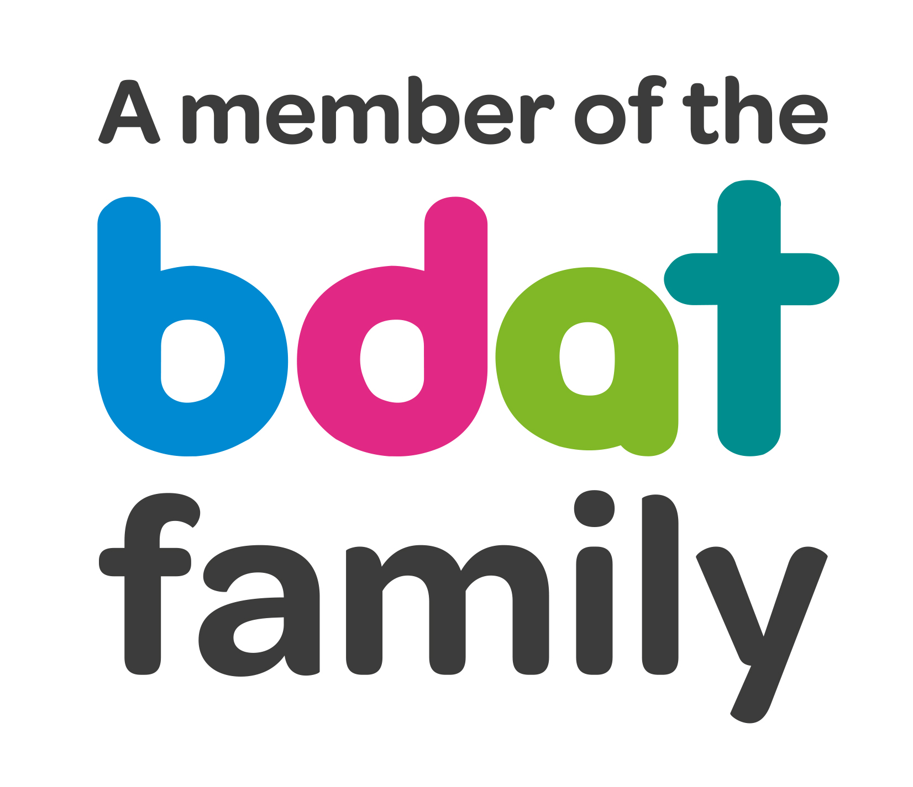
Christ Church Academy
Wrose Brow Road
Shipley
Bradford
BD18 2NT
01274 410349
admin@cca.bradford.sch.uk
Headteacher: Mrs Philippa Foster

Date: Friday 13th January 2023

YEAR 6 TRIP TO CLIFFE CASTE, KEIGHLEY
– THURSDAY 26th JANUARY

As part of the Year 6 curriculum, Miss Clarke would like to take the children to Cliffe Castle Museum in Keighley. Children will travel by train to reduce transport costs.

The cost of the trip is included in the £35 fee for ALL day trips this year. Please ensure this is paid (in instalments if preferred) by the end of April 2023.

Children should arrive at school by 8:50am and can be collected at the end of the school day at 3:10pm.

- Please sign the attached slip to give your consent for your child to attend. Your child cannot attend without consent. Please return this to school straight away.
- Please provide a packed lunch for your child. If your child is in receipt of free school meals, school will provide a packed lunch.
- School uniform must be worn. Please dress for the weather on the day, so a coat is required and good walking shoes.

If you have any queries, please contact the school office.

Yours sincerely,

Mrs Best
Office Manager

I consent to my child …………………………………………………………………. attending the Year 6 trip to Cliffe Castle on Thursday 26th January.

Does your child have any medical conditions or require medication? Yes/No
Please give details if answered Yes, and provide medication on the day.

Does your child have any dietary requirements/allergies? Yes/No
Please give details if answered Yes

Signed………………………………………………………………………………..Date:……………………………………………………………

