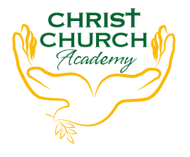
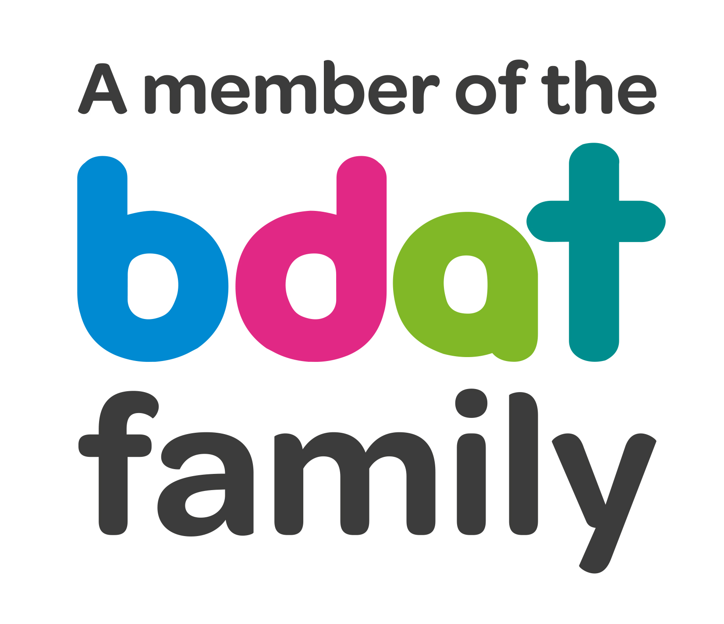
Christ Church Academy
Wrose Brow Road
Shipley
Bradford
BD18 2NT
01274 410349
admin@cca.bradford.sch.uk
Headteacher: Mrs Philippa Foster

Date: Friday 28th April 2023

YEAR 6 TRIP TO MEDIA MUSEUM, BRADFORD
– TUESDAY 16TH MAY

As part of the Year 6 Science curriculum, Miss Clarke would like to take the children to the Media Museum in Bradford. Children will travel by train to reduce transport costs.

The cost of the trip is included in the £35 fee for ALL day trips this year. Please ensure this is paid on ParentPay as soon as possible, if you haven’t done so already.

Children should arrive at school by 8:50am and can be collected at the end of the school day at 3:10pm.

- Please click below to give your consent for your child to attend. Your child cannot attend without consent.
- Please provide a packed lunch for your child. If your child is in receipt of free school meals, school will provide a packed lunch.
- School uniform must be worn. Please dress for the weather on the day, so a raincoat may be required and comfortable shoes.

If you have any queries, please contact the school office.

Yours sincerely,

Mrs Best
Office Manager

I consent to my child …………………………………………………………………. attending the Year 6 trip to Media Museum on Tuesday 16th May.

Does your child have any medical conditions or require medication? Yes/No
Please give details if answered Yes, and provide medication on the day.

Does your child have any dietary requirements/allergies? Yes/No
Please give details if answered Yes

Signed………………………………………………………………………………..Date:……………………………………………………………

