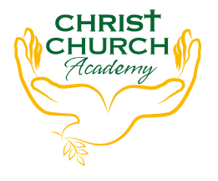
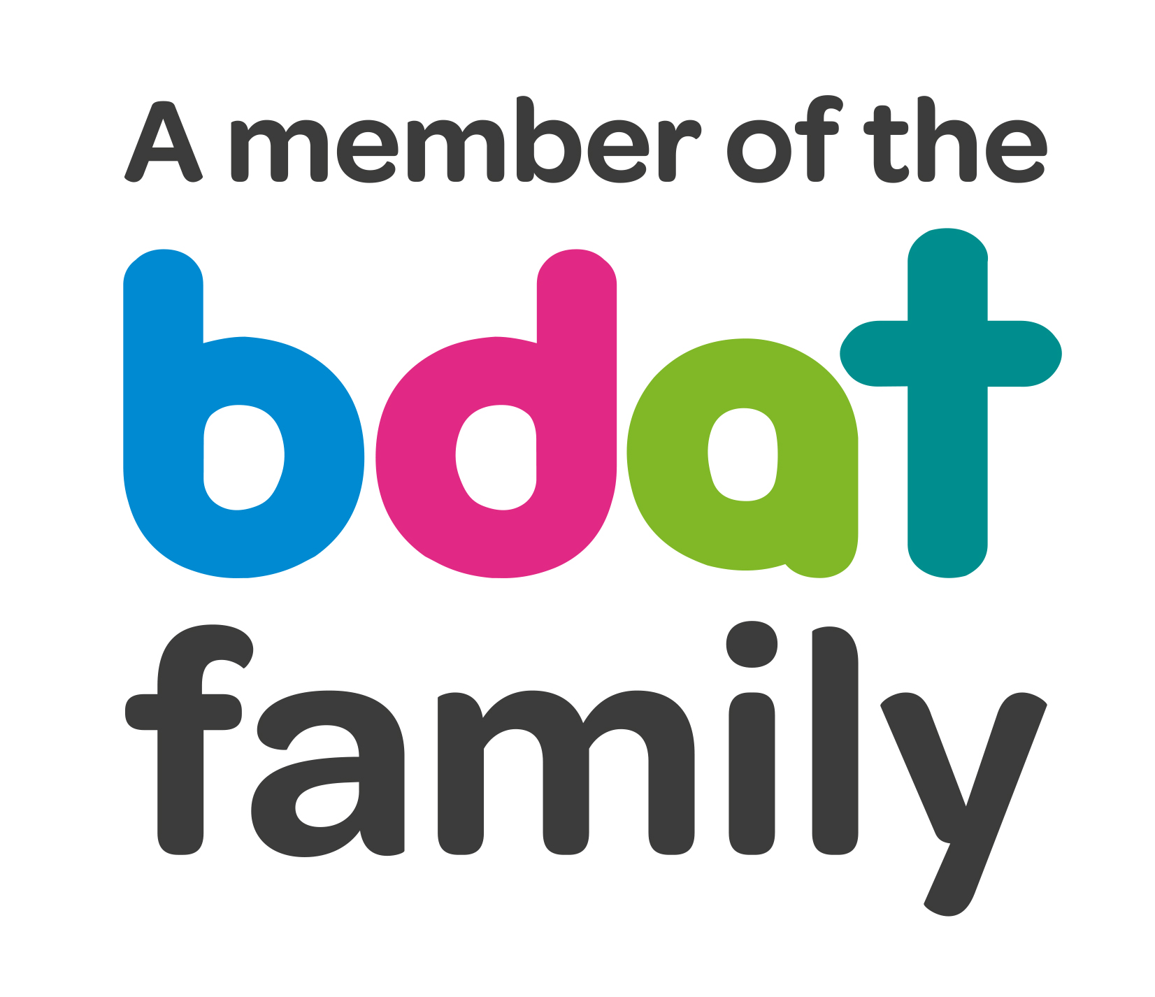
Christ Church Academy
Wrose Brow Road
Shipley
Bradford
BD18 2NT
01274 410349
admin@cca.bradford.sch.uk
Headteacher: Mrs Philippa Foster
Date: Friday 24th November 2023

YEAR 1 TRIP TO BRADFORD INDUSTRIAL MUSEUM
– THURSDAY 18TH JANUARY 2024

As part of Year 1’s topic about traditional toys, Mrs. Gallagher would like to take the children to Bradford Industrial Museum. Children will travel by coach to the museum in Eccleshill.

Children should arrive at school no later than 8:50am and can be collected at the usual time of approximately 3:20pm.

- The price of the trip is £15. Please pay (in instalments if preferred) on Parentpay. If you struggle to pay, please see the school office in confidence.
- Please provide consent by clicking on the link below
- Please provide a packed lunch for your child. If your child is in receipt of free school meals, school will provide a packed lunch.
- School uniform must be worn. Please dress for the weather on the day, so a coat is required.

If you have any queries, please contact the school office.

School Office

…………………………………………………………………………………………………………………………………………………………………….

I consent to my child …………………………………………………………………. attending the Year 1 trip to Bradford Industrial Museum on Thursday 18th January 2024.

Does your child have any medical conditions or require medication? Yes/No
Please give details if answered Yes, and provide medication on the day.

Does your child have any dietary requirements/allergies? Yes/No
Please give details if answered Yes

Signed…………………………………………………………..Parents name:……………………………………………………………………….

