Amy Conroy
CCA
Computing at CCA

How is Computing taught at Christ Church Academy

Intent
At Christ Church we are committed to ensuring that through computing lessons and exposure to technology, all our pupils are able to reach their full potential and use this to enhance their understanding of their curriculum and the wider world around them. By engaging with our computing curriculum learners are equipped with the skills, knowledge and understanding necessary to allow them to use technology effectively and confidently. Technology is ever evolving and so we aim at Christ church to allow all our children to opportunity to deepen their understanding of this but also make links between this and the wider curriculum in particular, Science, Mathematics, PHSE and Design technology. At Christ church we hope all our pupils leave us with deeper understanding of how they as a person can impact the wider world and this curriculum allows them to use technology safely and effectively, allowing them the ability to use and express their knowledge for the future.

All learning is planned to support and reinforce our Christian values, curriculum drivers and BDAT’s ICARE inclusion strategy.

Implementation

Through our use of the Teach Computing (NCCE) Scheme of Work, which is aligned to the National Curriculum, learners are equipped with the skills, knowledge and understanding necessary to allow them to use technology effectively and confidently. Use of this high-quality scheme enables us to ensure consistency and continuity in teaching and learning in Computing as this subject is predominantly taught by non-specialist teachers and HLTAs.

The Primary National Curriculum for Computing at Key Stage 1 and Key Stage 2 is split into three areas: information technology, digital literacy, and computer science.
- Information technology is about the use of computers for functional purposes, such as collecting and presenting information, or using search technology
- Digital literacy is about the safe and responsible use of technology, including recognising its advantages for collaboration or communication
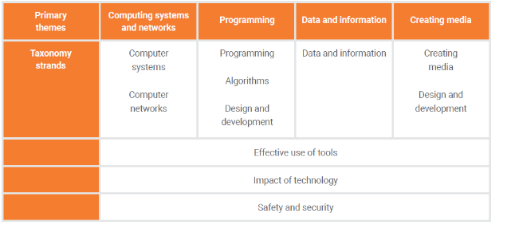
- Computer science helps children of all ages to understand how computers and networks work. It gives all children the opportunity to learn basic computer programming, from simple floor robots in Years 1 and 2, right up to creating on-screen computer games and programmes by Year 6, using programming software such as Scratch or Kodu.
Computer Science
Information Technology
The Teach Computing Scheme of Work follows the NCCE’s taxonomy of ten strands, which are aligned with the National Curriculum, and are mapped to four key themes. Each year each class (in Years 1-6) covers units within the same 4 themes, ensuring that units build on each other from one key stage to the next:
Digital Literacy
- Computing Networks and Systems (computer science)
- Programming (computer science)
- Data and Information (information technology)
- Creating Media (information technology)
*Digital literacy is embedded across all units of work, as well as within the comprehensive Online Safety units covered.
This approach allows us to use the spiral curriculum approach to progress skills and concepts from one year group to the next.
Cross-curricular use of technology and computing skills enables us to provide a broad and balanced curriculum which is enhanced by the effective use of technology.

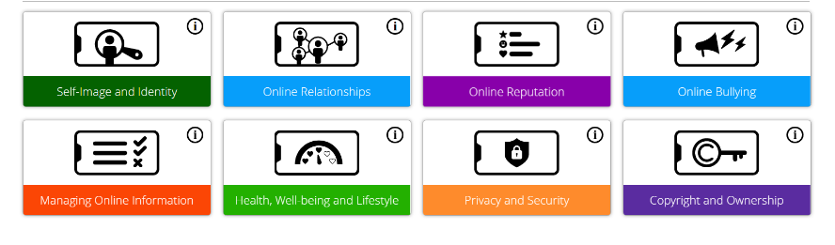
E-safety is explicitly taught within Computing lessons, using the Project Evolve materials. Teaching about E-safety is also linked into learning in PSHE where related topics are supported by Project Evolve E-safety resources. In addition to this, E-safety is embedded within all use of technology, both within and – wherever possible - outside of school.

Within Early Years, children are given opportunities to use and understand technology, considering its many uses in the environments known to them. See Document: ‘Detailed Computing skills progression from Nursery’

In Key Stage 1, learners participate in weekly computing lessons. They start by identifying the use of technology around them then start to access use of technology in school which enables them, initially, to gain confidence in using devices within the classroom and logging in, learning the importance of using passwords to keep their work and information secure. Learners are taught to understand basic programming, through the use of algorithms and precise instructions, moving on to creating and debugging simple programs. Learners use technology purposefully, to create, organise, store and manipulate information. Learners use classroom discussion to make links between information technology experiences in school, and those used in the wider world. Cross Curricular links are made wherever possible to enhance learning in other curriculum areas, such as Science.

In Key Stage 2, learners build on their understanding of computer science and computational thinking. They develop control systems using their programming skills to accomplish a specific goal. Learners use input and output systems, as well as sequence, selection and repetition in programmes. Building on their understanding of algorithms, children learn to describe how they work and further develop their ability to detect and correct errors in a program. Learners develop their understanding of larger networks such as the Internet and are able to explain how they work. Through their use of search technologies, children in Key Stage 2 develop their Digital Literacy skills, learning about how search results are selected and ranked, as well as developing their skills to challenge and check information presented for reliability. The collection, analysis, evaluation and presenting of data is further developed through application to other curriculum areas wherever possible.

By ensuring our PHSE and Computing lessons link through the use of project evolve we are able to map out the coverage of key e-safety strands across the year. There is a whole school focus day in the spring term as part of the Safer Internet day and where possible we try to share messages and new technological developments with parents to ensure they are given key information, sometimes through dojo, parent sessions with the WYP etc.
We also aim to ensure there is a focus on cross curricular work within the subject, as seen in the majority of end of unit assessments we try to ensure we can use the software they are learning to use to enhance other work in science, mathematics or towards their big question topic.

Impact
Learners will:
- know more, remember more and understand more about computing
- have the key skills, knowledge and understanding necessary to allow them to use technology effectively and confidently
and use it effectively to express themselves, develop their ideas and share information, both at home and in school
- use technology and the internet safely; knowing and understanding how to keep themselves safe
- be digitally literate and digitally resilient: knowing how to use and evaluate the trustworthiness of information found online, as well as deal with negative experiences online appropriately
- achieve age related expectations in computing

CCA Computing LTP
 | Autumn |  | Spring |  |  | Summer
NCCE Teach Computing Theme | Autumn 1:  Computing Systems and Networks (CS) | Autumn 2: Creating Media (IT) | E Safety focus for Safer Internet Day  (Project Evolve) (DL) | Spring 1: Programming A (CS) | Spring 2: Data and Information (IT) |  | Summer 1: Creating Media (IT) | Summer 2: Programming B  (CS)
EYFS | See document EYFS Detailed skill progression from Nursery
Reception | Know some similarities and differences between things in the past and now, drawing on their experiences and what has been read in class. |  | Privacy and Security
Year 1 | Technology Around Us 1.1  Recognising technology in school and using it responsibly.  Project Evolve link: Privacy and Security | Digital painting 1.2  Choosing appropriate  tools in a program to create art, and making comparisons with working non-digitally.  Project Evolve link: Privacy and Security | Managing Online Information | Moving a robot 1.3  Writing short algorithms and Programs for floor  robots, and predicting program outcomes. | Grouping data 1.4  Exploring object labels, then using them to sort and group objects by properties. |  | Digital writing 1.5  Using a computer  to create and format  text, before  comparing to writing  non-digitally. | Programming animations 1.6  Designing and programming the movement of a character on screen to tell stories.
Year 2 | Information Technology around us 2.1  Identifying IT and how its responsible use improves our world in school and beyond.  Project Evolve link: Managing Online Information | Digital Photography 2.2  Capturing and changing digital photographs for different purposes.  Project Evolve link: Online Relationships | Online Relationships | Robot Algorithms 2.3  Creating and debugging programs, and using logical reasoning to make predictions. | Pictograms 2.4  Collecting data in tally charts and using attributes to organise and present data on a computer. |  | Making music 2.5  Using a computer  as a tool to explore  rhythms and  melodies, before  creating a musical  composition. | Programming quizzes 2.6  Designing algorithms and programs that use events to trigger sequences of code to make an interactive quiz.
Year 3 | Connecting computers 3.1  Identifying that digital devices have inputs,  processes, and outputs, and how devices can be connected to make networks.  Project Evolve link: Privacy and Security | Stop frame animation 3.2  Capturing and editing digital still images to  produce a stop-frame animation that tells a story. | Privacy and Security  Online Bullying  Po | Sequencing sounds 3.3  Creating sequences ina block-based programming language to make music. | Branching databases 3.4  Building and using branching databases to group objects using yes/no questions. |  | Desktop Publishing 3.5  Creating documents  by modifying text,  images, and page  layouts for a  specified purpose. | Events and actions in programs 3.6  Writing algorithms and programs that use a range of events to trigger sequences of actions.
Year 4 | The Internet 4.1  Recognising the internet as a network of networks including the WWW, and why we should evaluate online content. | Audio editing 4.2  Capturing and editing audio to produce a podcast, ensuring that copyright is considered.  Project Evolve link: Privacy and Security | Health, Wellbeing and Lifestyle  Online Reputation | Repetition in shapes 4.3  Using a text-based programming  language to explore  count- controlled loops when drawing shapes. | Data logging 4.4  Recognising how and why data is collected over time, before using data  loggers to carry out an investigation. |  | Photo editing 4.5  Manipulating digital  images, and reflecting  on the impact of  changes and whether  the required purpose  is fulfilled. | Repetition in games 4.6  Using a block-based programming  language to explore  count-controlled and infinite loops when creating a game.
Year 5 | Sharing Information 5.1  Identifying and exploring how information is shared between digital systems.  Project Evolve link: Managing Online Information | Video Editing 5.2  Planning, capturing, and editing video to produce a short film. | Managing Online Information  Copyright and Ownership | Selection in physical computing 5.3  Exploring conditions and selection using a programmable microcontroller. | Flat-file databases 5.4  Using a database to order data and create charts to answer questions. |  | Vector drawing 5.5  Creating images  in a drawing program  by using layers and  groups of objects. | Selection in quizzes 5.6  Exploring selection in programming to design and code an interactive quiz.
Year 6 | Internet Communication 6.1  Recognising how the WWW can be used to communicate and be searched to find information.  Project Evolve link: Managing Online Information | Webpage creation 6.2  Designing and creating webpages, giving consideration to copyright,  aesthetics, and navigation.  Project Evolve link: Copyright and Ownership | Self Image and Identity (links to PSHE)  Privacy and Security | Variables in games 6.3  Exploring variables when designing and coding a game. | Introduction to spreadsheets 6.4  Answering questions by using spreadsheets  to organise and calculate data. |  | 3D modelling 6.5  Planning, developing,  and evaluating 3D  computer models of  physical objects. | Sensing 6.6  Designing and coding a project that captures inputs from a physical device

CCA Computing Unit End Points (including software/hardware)
 | Autumn |  | Spring |  | Summer
EYFS | See document EYFS Detailed skill progression from Nursery
Year 1 | Technology Around Us 1.1  Paintz.app  To create a list of technology in school with tips for safe usage | Digital painting 1.2  MS Paint  To create a digital painting linked to world around us topic | Moving a robot 1.3  Beebots  To programme a robot to make a sequence of movements | Grouping data 1.4  MS Powerpoint  To sort data linked to science properties and materials | Digital Writing 1.5  MS Word  To create a sign or information label linked to seasonal changes | Programming animations 1.6  Scratch Jr (iPads)  To programme a character in screen to tell a story linked to English.
Year 2 | Information Technology around us 2.1  MS Powerpoint  To create a charter for using technology responsibly | Digital Photography 2.2  Digital Camera or iPads  To create and edit a photo linked to excitable edgar. | Robot Algorithms 2.3  Bee-bots and Blue-bot  To programme a robot to make a sequence of movements | Pictograms 2.4  J2E Pictogram (online)  To represent data in a tally chart and present it on a computer (linked to maths) | Making music 2.5  Chrome Music Lab (online)  https://musiclab.chromeexperiments.com/  To create a tune with a theme linking to journey story writing | Programming quizzes 2.6  Scratch Jnr (iPad App)  To make an interactive quiz to collect information linked to tropical world topic focus
Year 3 | Connecting computers 3.1  Paintz.app (Online)  https://paintz.app/  To create a labelled diagram of a network | Stop frame animation 3.2  iMotion (iPads)  To create a stop frame animation linked light topic/shadow | Sequencing sounds 3.3  Scratch (Online)  To create a podcast linked to PHSE | Branching databases 3.4  J2E Branch and Pictogram (online)  https://www.j2e.com/j2data/  To create a branching database linked to science | Desktop Publishing 3.5  Adobe Express (App)  To present non-chronological report linked to Pompeii electronically | Events and actions in programs 3.6  Scratch (Online)  To create a programme to represent learning about our bodies (Science)
Year 4 | The Internet 4.1  Various Websites  To write a brief explanation about how it is important to evaluate online content | Audio editing 4.2  Audacity (App)  To create a podcast linked to English story | Repetition in shapes 4.3  FMSLogo  To create a repeating pattern | Data logging 4.4  Data Logger (Physical equipment)  To use data loggers to collect data over time in science (materials) | Photo editing 4.5  MS Photos  www.befunky.com (online)  To create an image linked to PSHE | Repetition in games 4.6  Scratch (Online)  To create repetition in a game
Year 5 | Sharing Information 5.1  MS Powerpoint  To create a sequencing frame to show how data is shared between digital systems | Video Editing 5.2  MS Video Editor (App)  To produce a short film linked to how Greece shaped the world around us | Selection in physical computing 5.3  Crumble controller + start kit + motor  To use and programme a microcontroller | Flat-file databases 5.4  J2E Database (online)  https://www.j2e.com/j2data/  To create and use a flat file database to answer questions linked to science | Vector drawing 5.5  Powerpoint  To create a piece of art using skills learnt | Selection in quizzes 5.6  Scratch  To design and code an interactive quiz to test y5 curriculum knowledge
Year 6 | Internet Communication 6.1  Unplugged  To write a top tips instruction sheet to help a new user search the WWW effectively | Webpage creation 6.2  Microsoft Sway  To create a webpage to share learning based on Charles Darwin topic | Variables in games 6.3  Scratch (Online)  To design and code a game linked to a historical era studied in KS2 | Introduction to spreadsheets 6.4  MS Excel  To use a spreadsheet to organise and calculate data linked to science/maths | 3D modelling 6.5  Tinkercad (online)  To plan, develop and evaluate a 3D model of an object | Sensing 6.6  Micro:bit and MS MakeCode (Physical equipment and online)  To design and code a project that captures inputs from a physical device

E-safety Mapping (Project Evolve)
 | Autumn |  | Spring |  | Summer
Reception |  |  | Privacy and Security
Year 1 | Privacy and Security | Privacy and Security | Managing Online Information
Year 2 | Managing Online Information | Online Relationships | Online Relationships
Year 3 | Privacy and Security |  | Privacy and Security  Online Bullying
Year 4 |  | Privacy and Security | Health, Wellbeing and Lifestyle  Online Reputation
Year 5 | Managing Online Information |  | Managing Online Information  Copyright and Ownership  Online Bullying
Year 6 | Managing Online Information  Copyright and Ownership |  | Self Image and Identity (links to PSHE)  Privacy and Security
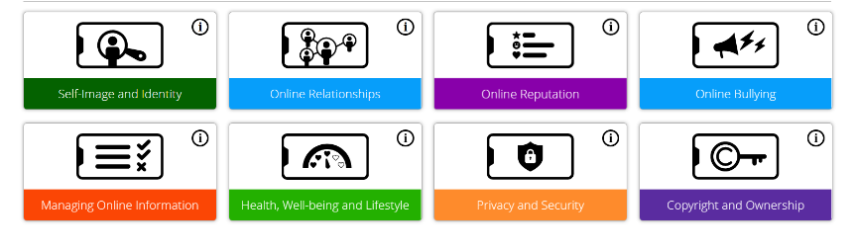

Teach Computing (NCCE) Overview Y1-6
Key Stage 1
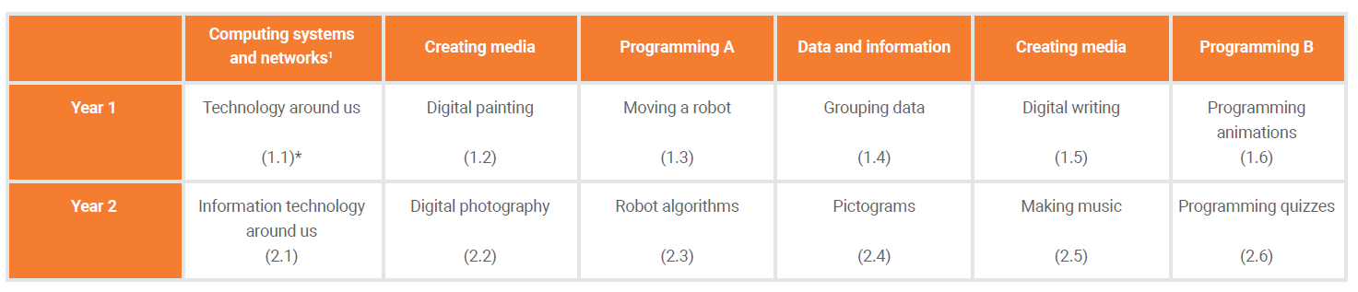
Key Stage 2
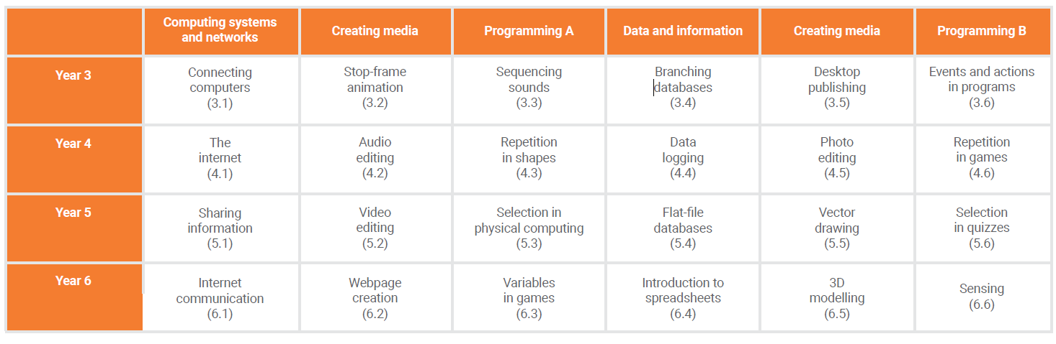

National Curriculum Objective Mapping – for Assessment
Key Stage 1
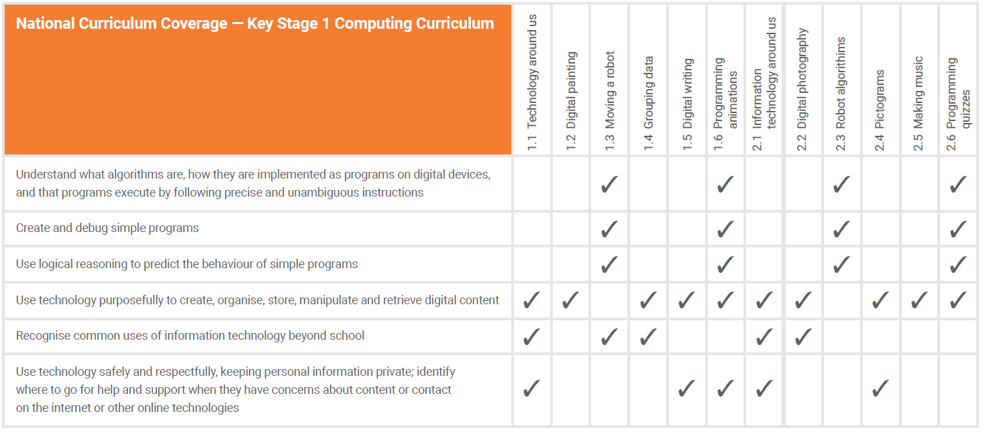

Lower Key Stage 2
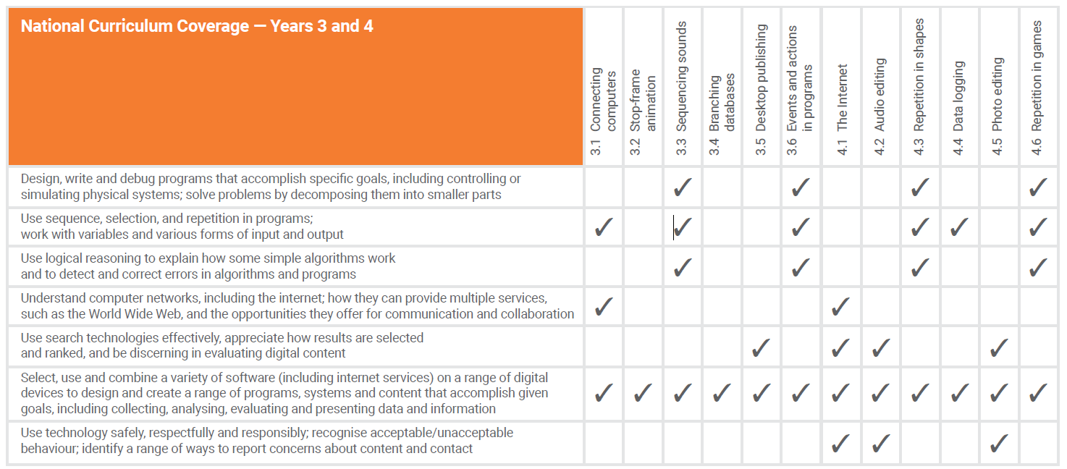
Upper Key Stage 2
